**Hook Form**

Create a form like the following wireframe with a React Component and hooks. Then, show in real time, the data that is being inputted into the form below

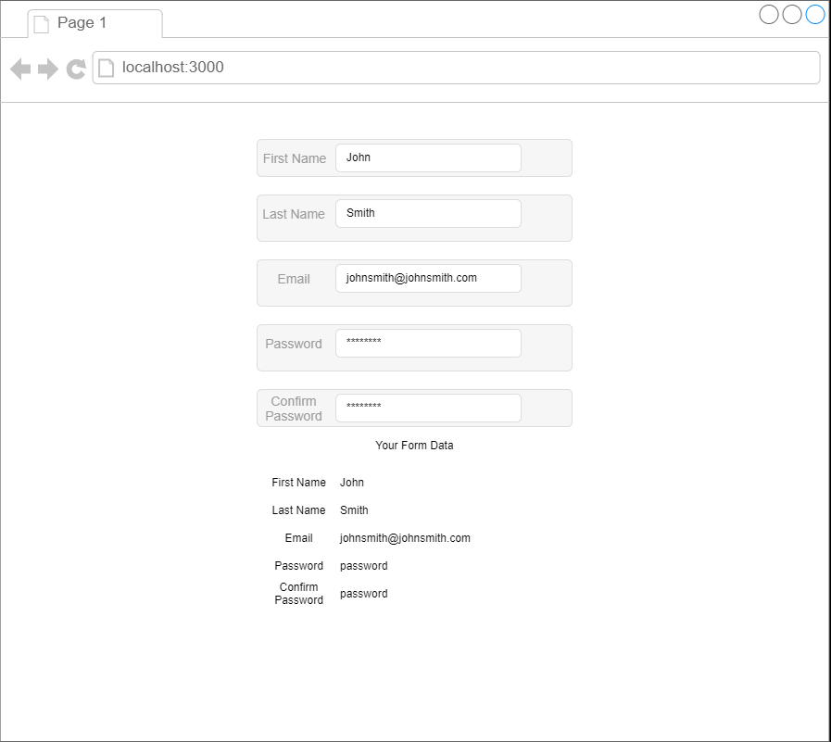

* Create form inputs with First Name, Last Name, Email, Password and Confirm Password fields
* Display, in real time, the form data that is being typed in below the form